Conclusion:
Need to use PDEPE with 20 grid points and tolerences 0.01.
Can use implicit with 30 grid points and dt = 0.1. With more grid points need to reduce dt

-------------

PDEPE with 30 grid points (30 sec)
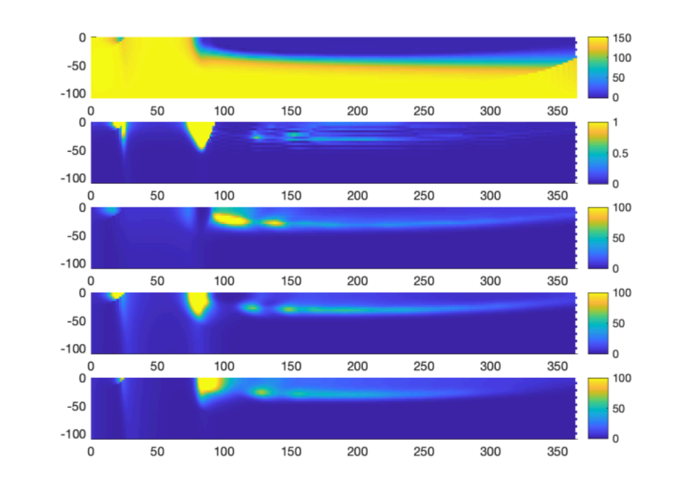
ImplicitPC, dt = 0.1, (7.6 sec)
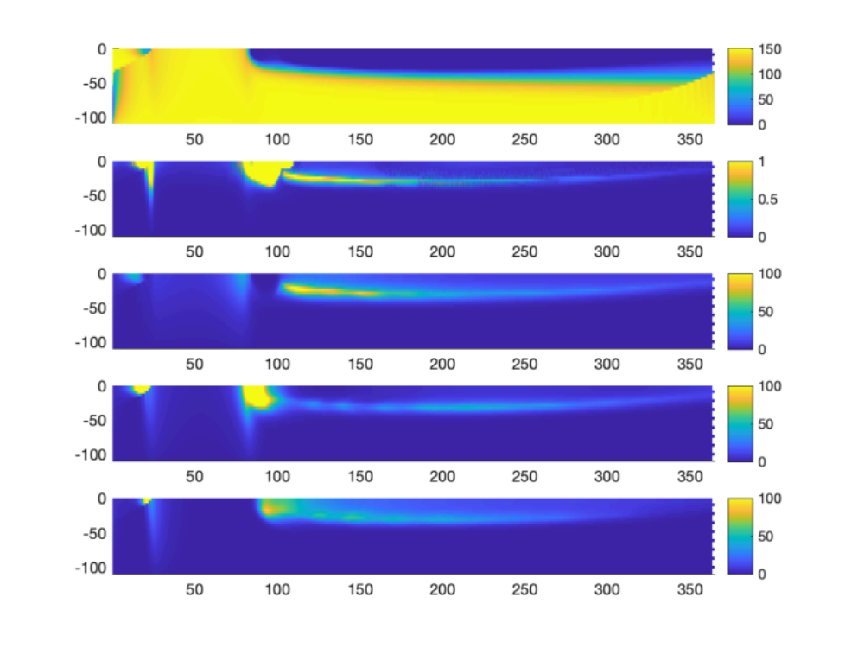
Implicit, dt = 0.1: 4.34 sec
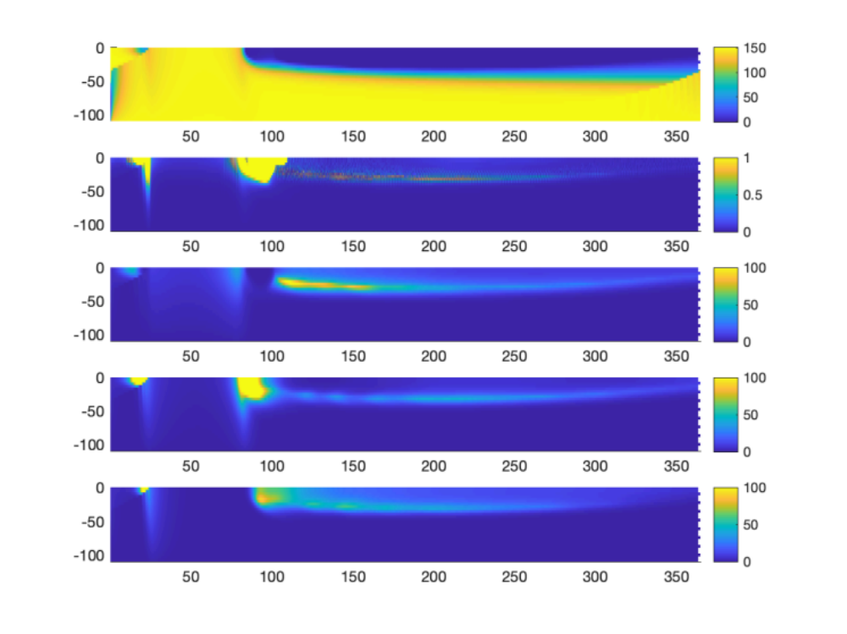
Implcity with dt = 1, 0.25, 0.05, 0.01 (yellow, green, blue, black). Conclusion: 0.1 ok.
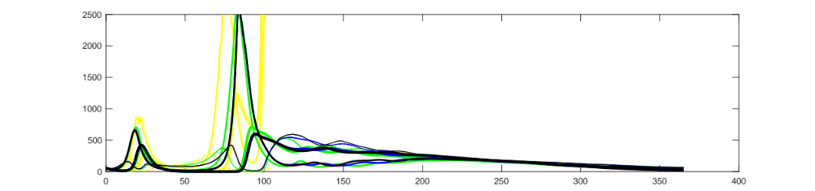
Compare Implicit (green) ImplicitPC (blue) and PDE (black). Implicit and PC are similar. Implicit scheme is fine!

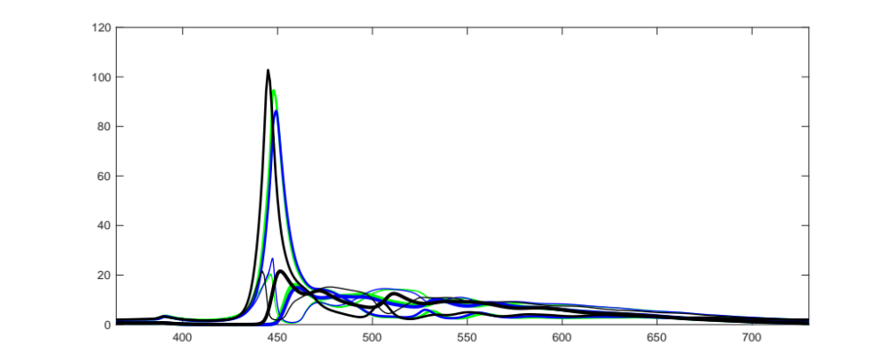

Implicit with dt = 0.1 and nGrid = 10, 30, 100:
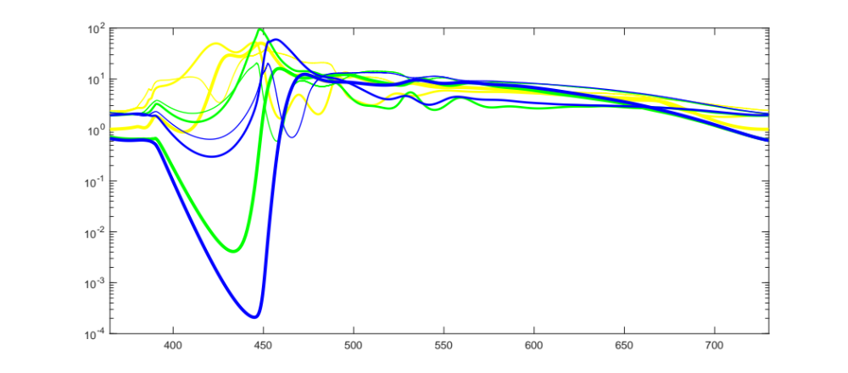
Implicit with nGrid = 10, 30, 100 and adjusted dt 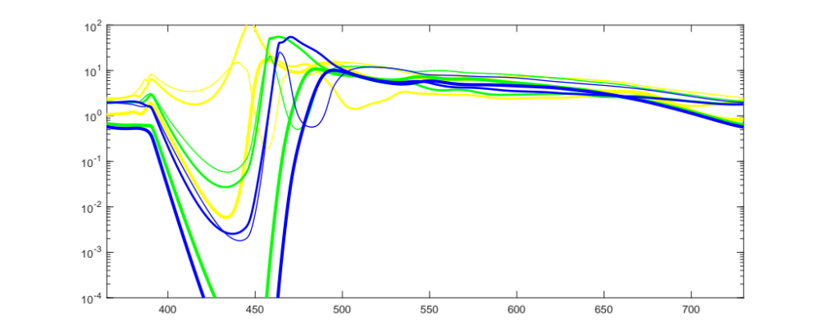
Full with nGrid = 20 (25 sec), 30, 100:

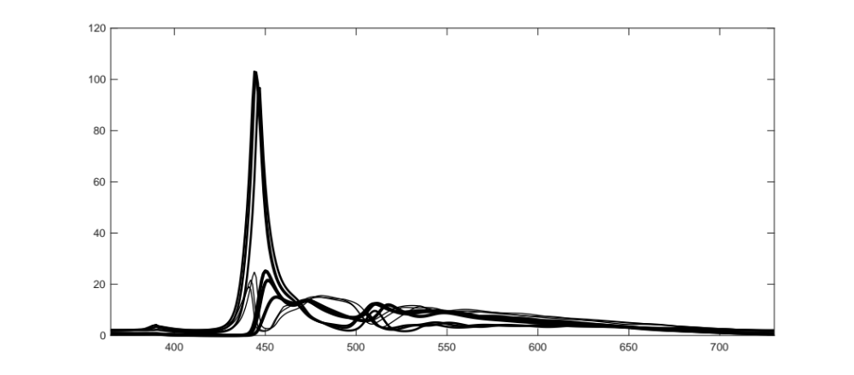
Full with nGrid = 20 and tolerences = 1e-6, 1e-3 (20 sec), 0.01 (18 sec), 0.1 (14 sec):
